IT and Systems Infrastructure

**RAID** – *Redundant Array of Independent Disks*

* *Storage virtualization technology that combines multiple physical disk drive components into one or more logical units for data redundancy, performance improvement, or both.*
* *Way of storing the same data in different places on multiple hard disks to protect data in case of drive failure.* **Not all RAID levels provide redundancy.**
* *RAID works by placing data on multiple disks and allowing I/O operations to overlap in a balanced way, improving performance.*
* *RAID arrays appear to the operating system as a single logical hard disk*
* *RAID employs the techniques of disk mirroring or disk striping. Mirroring copies identical data onto more than one drive. Striping partitions each drive’s storage space into units ranging from a sector (512 bytes) up to several megabytes. The stripes of all the disks are interleaved and addressed in order.*

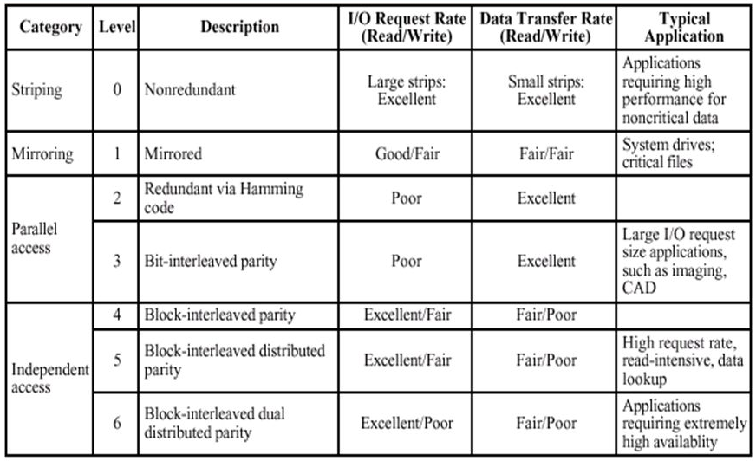**RAID Levels**

**Nested Raid/Hybrid RAID –**

* *Combines two or more standard RAID levels to gain performance, additional redundancy or both.*
* *RAID 5+0 (RAID 50) – Layers the data striping of RAID 0 on top of the distributed parity of RAID 5.*
* *Nested RAID levels include RAID 01, RAID 10, RAID 100, RAID 50 and RAID 60, which all combine data striping with other RAID techniques; as a result of the layering scheme, RAID 01 and RAID 10 represent significantly different nested RAID levels.*

**RAID 0 –**

* *Has striping but no redundancy of data.*
* 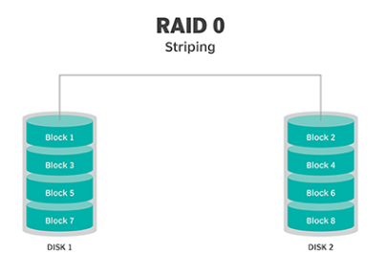*Offers best performance, but no fault tolerance.*

**RAID 1 –**

* *Known as disk mirroring*
* *Consists of at least two drives that duplicate storage of data*
* *No striping*
* *Improved read performance – either disk can be read at the same time.*
* *Write performance same as single disk storage.*

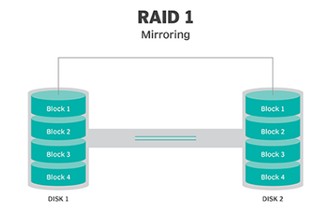

**RAID 2 –**

* *Uses data striping across disks*
* *Some disks store error checking and correcting information (ECC)*
* *No advantages over RAID 3*
* ***Not used anymore***

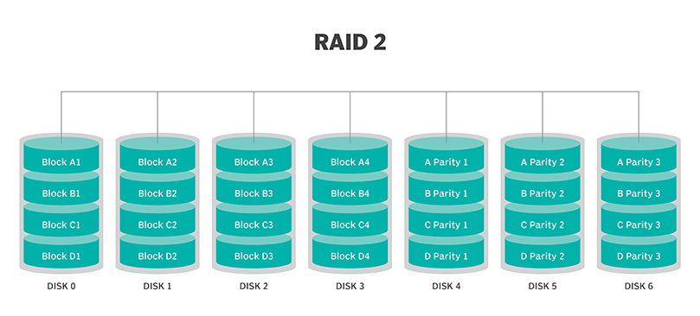

**RAID 3 –**

* *Uses data striping*
* *Dedicated one drive to storing parity information*
* *Embedded ECC information used to detect errors*
* *Data recovery accomplished by calculating XOR of the information recorded on other drives*
* *Cannot overlap I/O operation (Since I/O operation addresses all drives at the same time)*
* 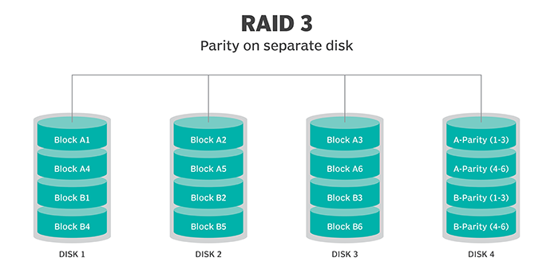***Best for single-user systems with long record applications***

**RAID 4 –**

* *Large stripes (Can read records from any single drive)*
* *Can use overlapped I/O for read operations (Since all write operations have to update the parity drive, no I/O overlapping is possible*
* ***No advantages over RAID 5***

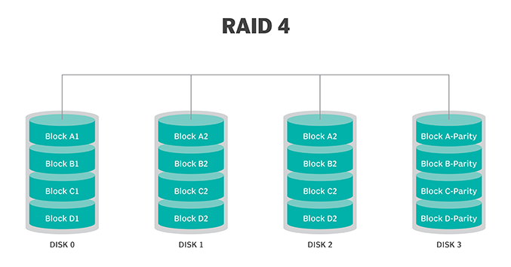

**RAID 5 –**

* *Block-level striping with parity*
* *Parity information striped across each drive, allowing array to function even if one drive were to fail.*
* *Allows read and write operations to span multiple drives (This results in performance that is usually better than that of a single drive, but not as high as that of a RAID 0 array)*
* *Requires at least 3 disks (5 Disk recommended for performance reasons)*
* *Bad choice for write-intensive systems because of the performance impact associated with writing parity information)*
* *Long time to rebuild RAID 5 array when disk does fail.*
* *Performance degraded during rebuild time*
* *Array is vulnerable to additional disk failure until rebuild is complete*

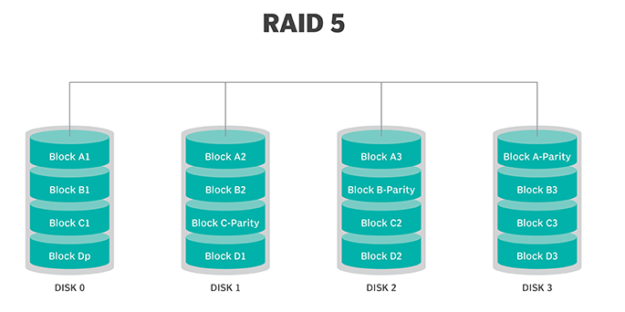

**RAID 6 –**

* *Similar to RAID 5*
* *Includes second parity scheme that is distributed across drives in array*
* *Use of additional parity allows array to continue to function even if two disks fail simultaneously*
* *Arrays have higher cost per gigabyte*
* *Slower write performance than RAID 5 arrays*

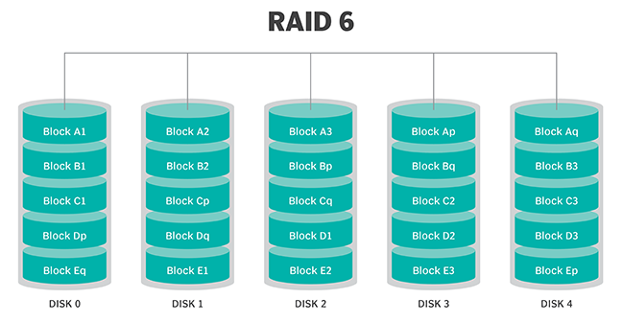

**Disk Striping –**

* *Process of dividing a body of data into blocks and spreading data blocks across multiple storage devices, such as hard disks or solid state drives (SSDs)*
* *Consists of data divided across set of hard disks or SSDs, and a striped unit, or strip, that refers to the data slice on an individual drive*
* *Higher performance (striping data across three hard disks provides three times the bandwidth of a single drive)*
* *Low resilience – Failure of any physical drive in the striped disk set results in loss of data on striped unit, and consequently, the loss of the entire data set stored across the set of striped hard disks*
* *Used by RAID to distribute and store data across multiple physical drives.*
* *Synonymous with RAID 0 and spreads data across all disk drives in RAID group without parity*
* *Disk striping without parity is not fault tolerant.*
* *Disk striping without RAID may be used for temporary data, scratch space, or in situations where master copy of the data is easily recoverable from another storage device*

**Disk striping with parity –**

* *Addresses potential for data loss with RAID 0 (RAID set typically uses at least one stripe for parity)*
* *Provides redundancy and reliability*
* *RAID 4 and RAID 5 protect against single drive failure*
* *RAID 6 uses two drives for parity and protects against two drive failures*
* *Data protection can be extended beyond two storage device failures using erasure coding*
* *Performance penalty for small random writes as system accesses all the stripe units in the striped RAID set.*

**Disk striping and disk mirroring –**

* *Disk striping can be combined with disk mirroring, or RAID 1, to speed performance and expand capacity by striping data across multiple sets of mirrored drives.*
* *50% overhead in using half the capacity to make an exact copy of the data for protection.*

**Erasure Coding**

* *Method of data protection*
* *Data is broken into fragments, expanded and encoded with redundant data pieces and stored across a set of different locations or storage media*
* *Enables data that becomes corrupted in disk storage process to be reconstructed by using information about the data that’s stored elsewhere in the array*
* *Used instead of traditional RAID*